Camera-Ready Abstract Template for

2025 International Conference on

Flexible and Printed Electronics (ICFPE)

Author1, Author1,2, and Author3\*

1 AA University, Japan

2 BB University, Japan

3 CC University, Japan

\*Corresponding: …@ …

Abstract

Please submit an A4 size 1 Page abstract for describing contents discussed in the conference. Underline the presenting author’s name.

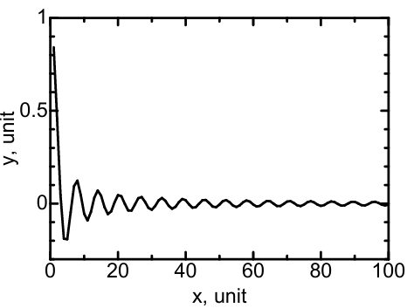

Figure 1. please add an caption for concise explanation.

References

[1]

[2]

[3]